
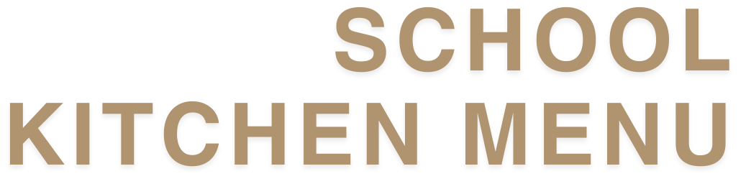

TERM 1, 2026

Weekly Specials - $7.00 each
WEEK 1 (27 Jan) |  | WEEK 2 (2 Feb)
No Special |  | Pita Pocket Beef Tacos
WEEK 3 (9 Feb) |  | WEEK 4 (16 Feb)
Crumbed Fish Fingers & Gems |  | Sweet & Sour Pork with Rice
WEEK 5 (23 Feb) |  | WEEK 6 (2 Mar)
Crumbed Chicken Nuggets |  | Chicken Burrito
WEEK 7 (9 Mar) |  | WEEK 8 (16 Mar)
Vegetarian Fried Rice |  | Beef Lasagne with Garlic Bread
WEEK 9 (23 Mar) |  | WEEK 10 (30 Mar)
Hotdog with tomato sauce & cheese |  | No Special
Melts - $6.00 each
Smokey BBQ Chicken Melt |  | Chicken Parmy Melt
Chicken, bacon, smokey BBQ sauce, mayo & cheese on Turkish |  | Chicken parmy, Napoli sauce, ham, mozzarella cheese
Ham & Pineapple Melt
Pineapple pieces, smoked ham, cheese & Napoli sauce
Sandwiches
Vegemite, strawberry jam or honey | $4.00 | Vegemite & cheese | $4.50
Cheese | $4.00 | Tomato & cheese | $4.50
Ham & cheese | $4.50 | Chicken, cheese & mayo | $5.00
Chicken, cheese & mayonnaise | $5.00 | Ham & salad | $5.50
Ham, cheese & tomato | $5.00 | White, wholemeal or gluten-free bread | $1.50
Add salad to any sandwich | $1.00 | Toasted - Toast your sandwich from home | 0.50c

Wraps & Salads - $6.00 each
Bacon & egg wrap |  | Chicken Caeser
Scrambeld egg, bacon, cheddar cheese, hash brown, BBQ sauce |  | Rotisserie chicken, bacon, lettuce, tomato, mozzarella cheese, Caeser dressing in a white wrap
Chicken Teriyaki
Teriyaki chicken, tomato, cucumber, carrot, crispy lettuce, kewpie mayo
Gourmet Range
Muffin of the Week | $5.00 | Chunky Choc Chip Cookie | $5.00
Baked Goods
Chocolate brownie (GF available) | $2.50 | Caramel slice | $3.00
Apple Danish | $3.00 | Cheesecake Strawberry Sponge | $3.00

Pastries
Small pie | $3.50 | Large steak, bacon & cheese pie | $5.50
Small sausage roll | $3.50 | BBQ Puffy Dog | $5.50
Large sausage roll | $5.50 | BBQ or tomato sauce | 0.50c
Large steak pie | $5.50
From the Cabinet/Snacks
Garlic bread | $2.00 | Jelly & custard | $2.50
Apple slinky | $2.50 | Fresh fruit salad | $3.00
Jelly cup | $2.00 | Frozen yoghurt | $3.00
 |  | Wild berry, mango or strawberry
Icy Swing | $3.00 | Frozen Milk Moosies | $2.50
Raspberry, Cola, Lemonade |  | Chocolate, banana, strawberry
Red Rock Chips | $2.50 | Popcorn | $1.00
Honey soy chicken or sweet chilli & sour cream |  | Mini cinnamon churro x 2 | $3.00
Drinks
Fruit juice 500 ml | $4.50 | Krazy Lemon 500 ml | $5.00
Orange & passionfruit, orange & mango |  | Flavoured Milk 250 ml | $4.00
Just Juice 200 ml | $3.50 | Strawberry, choc
Apple, apple & blackcurrant, orange |  | Flavoured Milk 500 ml | $5.00
Bottled water 600 ml | $3.50 | Choc, iced coffee, strawberry
Glee Sparkling Fruit Juice | $4.00
Birthday Mini Callipos
Delivered to your child’s classroom (48 hours’ notice required by email to: tuckshop@ccps.qld.edu.au) |  |  | $2.50 each

Smart Choices
Smart choices use a green, amber and red traffic light rating system of food and drink classification based on nutrient content, and is aligned with the Australia Dietary Guidelines
= Good
= Select Carefully
= Occasional

