
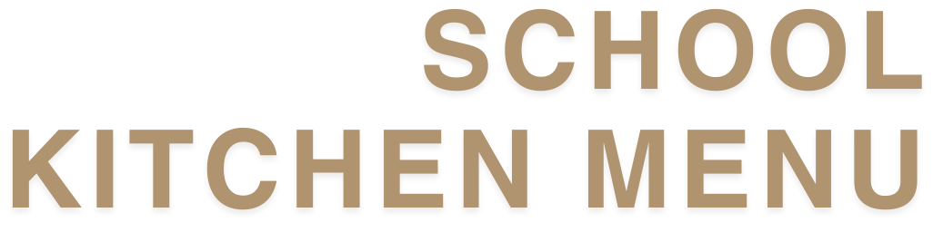

TERM 4, 2025

Weekly Specials | $6.00 each | Melts | $5.00 each
WEEK 1 (7 Oct) |  | Smokey BBQ Chicken Melt
No Special |  | Chicken, bacon, smokey BBQ sauce, mayo & cheese on Turkish
WEEK 2 (13 Oct) |  | Mexican Melt
Cheeseburger |  | Taco mince, rice, salsa, cheese & corn chip crunch
WEEK 3 (20 Oct) |  | Chicken Parmy Melt
Spaghetti & Meatballs |  | Chicken parmy, Napoli sauce, ham, mozzarella cheese
WEEK 4 (27 Oct) |  | Sandwiches
Pulled Beef Nachos |  | Vegemite, strawberry jam or honey | $3.50
WEEK 5 (3 Nov) |  | Vegemite & cheese | $4.00
Flame grilled chicken burger |  | Cheese | $3.50
WEEK 6 (10 Nov) |  | Tomato & cheese | $4.00
Chilli Con Carne with Rice |  | Ham & cheese | $4.00
WEEK 7 (17 Nov) |  | Chicken & cheese | $4.50
Tempura Chicken nuggets |  | Chicken, cheese & mayonnaise | $5.00
WEEK 8 (24 Nov) |  | Ham & salad | $5.00
Steamed Dim Sims with soy sauce |  | Ham, cheese & tomato | $4.50
WEEK 9 (1 Dec) |  | White, wholemeal or gluten-free bread | $1.00
No Specail |  | Toasted
 |  | Toast your sandwich from home | 0.50c
 |  | Add salad to any sandwich | $1.00

Wraps & Salads |  | Baked Goods
Bacon & egg wrap | $5.00 | Chocolate brownie (GF available) | $2.00
Scrambeld egg, bacon, cheddar cheese, hash brown, BBQ sauce |  | Caramel slice | $2.50
Chicken Teriyaki | $5.00 | Chocolate cake | $2.50
Teriyaki chicken, tomato, cucumber, carrot, crispy lettuce, kewpie mayo |  | Mint hedgehog slice | $2.50
Peri Peri Beef | $5.00 | Gourmet Range
Shaved beef, carrot, cucumber, crispy lettuce, tomato, Peri Peri mayonnaise |  | Muffin of the Week | $5.00
 |  | Chunky Choc Chip Cookie | $5.00

Pastries |  | From the Cabinet/Snacks
Small pie | $3.00 | Garlic bread | $1.50
Small sausage roll | $3.00 | Jelly & custard | $2.00
Large sausage roll | $4.50 | Apple Slinky | $1.50
Large steak pie | $5.00 | Fresh Fruit Salad | $2.00
Large steak, bacon & cheese pie | $5.00 | Jelly cup | $1.50
BBQ Puffy Dog | $4.50 | Frozen yoghurt | $2.50
BBQ or tomato sauce | 0.50c | Vanilla & caramel, mango & watermelon, strawberry & vanilla
Drinks |  | Icy Swing | $3.00
Fruit juice 500 ml | $4.00 | Raspberry, Cola, Lemonade
Orange & passionfruit, orange & mango |  | Frozen Milk Moosies | $2.00
Just Juice 200 ml | $3.00 | Chocolate, banana, strawberry
Apple, apple & blackcurrant, orange or paradise punch |  | Red Rock Chips | $2.50
Bottled water 600 ml | $3.50 | Honey soy chicken or sweet chilli & sour cream
Krazy Lemon 500 ml | $4.50 | Popcorn | $1.00
Flavoured Milk 500 ml | $4.50 | Mini cinnamon churro x 2 | $3.00
Choc, iced coffee, strawberry
Groove Sparkling Water 350 ml | $3.50
Birthday Mini Callipos
Delivered to your child’s classroom (48 hours’ notice required by email to: tuckshop@ccps.qld.edu.au) |  |  | $2.50 each

SMART CHOICES
Smart choices use a green, amber and red traffic light rating system of food and drink classification based on nutrient content, and is aligned with the Australia Dietary Guidelines
= Good
= Select Carefully
= Occasional

